Friday, June 7, 2024 - 7:00 a.m. – 5:00 p.m.
The Breakers Hotel
1 S. County Road, Palm Beach, Florida

MEETING REGISTRATION FORM

In-Person (FAAA Members) | $350 (includes FSA Registration Fee) |  | Membership (New) | $150
In-Person (Non-Members) | $495 (includes FSA Registration Fee) |  | Membership (Renewing) | $125
Virtual (Member) | $175 |  | Late Registration  (if registering after June 1, 2024) | $50
Virtual (Non-Member) | $250 |  | Total Enclosed | $

Name:_________________________________________ email:_________________________________________

Name:_________________________________________ email:_________________________________________

Name:_________________________________________ email:_________________________________________

Company:_______________________________________________________________________________________________

Company Mailing Address:________________________________________________________________________________

City:_________________________________ State:__________________________ Zip:_____________________

Phone:_______________________________ Fax:___________________________ Contact:__________________

Payment Method | Payee
Zelle | thefaaa2001@gmail.com
Credit Card* | FAAA (Please provide an email address for delivery of the invoice; You will pay this securely online via Chase). All major credit cards accepted.
Check | FAAA (See address and contact below)
*Your credit card statement will read “DB Healthcare Consulting”

Check enclosed for: $__________________

Please make your check payable to FAAA and mail it to:

Florida Anesthesia Administrators Association
Attention: Kelly Dennis
c/o Perfect Office Solutions Phone: 1-352-787-7869
P O Box 490447 Email: thefaaa2001@gmail.com
Leesburg, FL 34749-0447
Hotel Information:

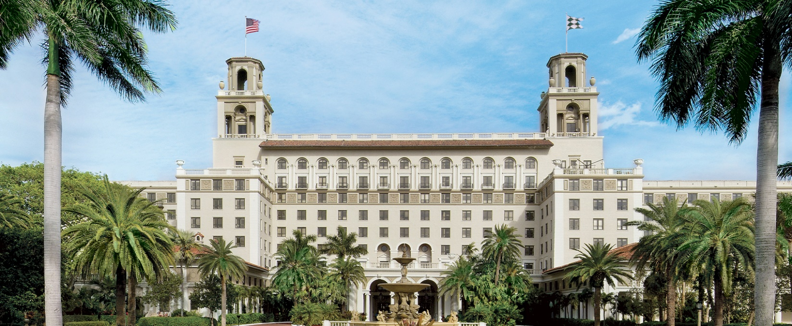
https://www.thebreakers.com/

The Breakers – we have one (1) room available at $302.00 per night + tax at the FSA group rate, available by lottery to FAAA members. Option to attend from 6/6 through 6/8/24 or to change the dates by May 15, 2024.

Please email spetersconsulting@yahoo.com by 1:30 p.m. on April 12, 2024, if you would like to be considered for the lottery.

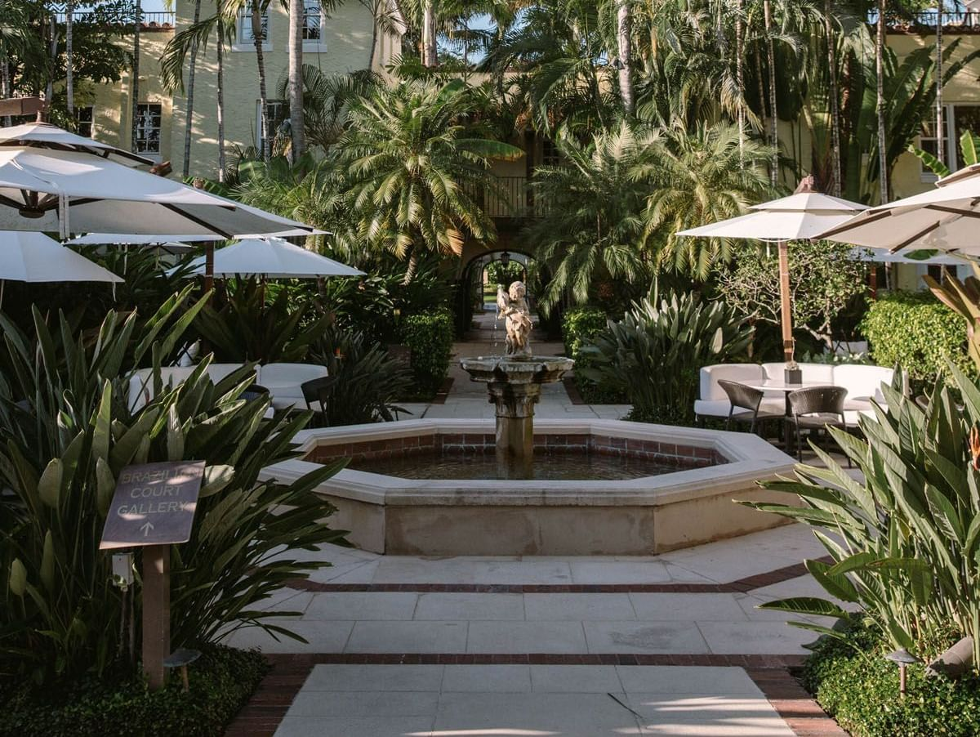
http://www.thebraziliancourt.com/

The Brazilian Court (1.4 miles from The Breakers) - 10 block rooms for Thursday, Friday, and Saturday are available at $310.00 per night + tax, with complimentary parking.

301 Australian Ave, Palm Beach, FL 33480, Call Group Reservations at (561) 655-7740

Must mention FAAA Room Block – register BEFORE 5/7/24 when our block expires. FSA Sold out of Breakers rooms and is also using The Brazilian Court!

Or - book a hotel nearby, if you are able to find a better rate! Please send questions to any FAAA Board member. We hope to see you there, and thank you for continuing to support the FAAA!

